The Special Interest Group of Municipal Authorities (Outside London)

SIGOMA RESPONSE TO THE POLICY PAPER ON COVID-FUNDING FOR 2021-22

- About SIGOMA
  - This submission is made on behalf of SIGOMA, the Special Interest Group of Municipal Authorities. We welcome the opportunity to respond to the consultation.

  - SIGOMA is a special interest group (within the LGA) representing 47 local authorities covering key urban areas in the North West, East and West Midlands, the North East, Yorkshire & Humberside and the South-coast; consisting of 33 metropolitan districts and 14 major unitary authorities.

  - In demographic profile SIGOMA councils comprise 6.1 million households, over 25% of England’s total but are over-represented in poverty indicators and the related demand for services whilst at the same time under-represented in terms of council tax and business rate earnings, increasingly influential in the funding framework for local government

  - Many of our members in were within the highest tiers of local lockdown prior to this latest national event. Over the 5 months to July the number of covid related deaths in the most deprived decile was 30% higher than that of the least deprived decile.

Covid Deaths per 100,000 March to July
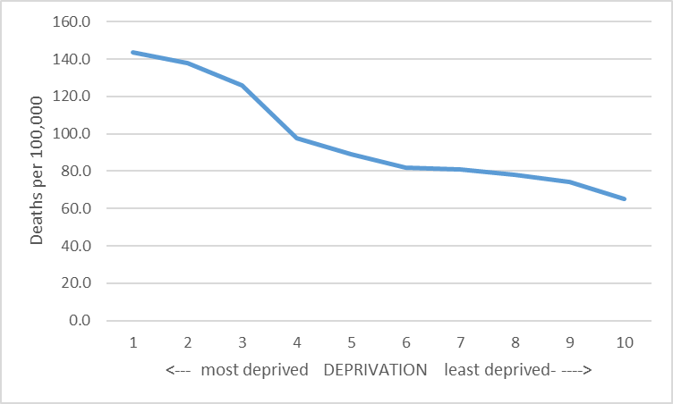

  - Over that period, whilst the average mortality rate was 91 per 100,000 the average rate for our members was 113.

  - It is, therefore, vital that government continues to place emphasis on deprivation when considering the likely funding needs of councils in response to the pandemic.

- Q1: Do you agree with our policy proposal to distributing £670 million of local council tax support?

  - Members support the use of average working age LCTS claimants as a means of allocation.

  - Members are less sure that the use of average council tax to further weight allocations will yield a fair distribution.

  - Logic would suggest that the tax weighting of those in need of support is likely to be skewed towards the lower end of banding.

  - A possible consequence is that councils with higher bands in their mix are likely to be able to offer more generous support relative to the tax charge than those in poorer ones.

  - As we assume the end aim is for potential claimants to benefit to the same extent across the country, we would suggest the use of an average weighted more towards average band D tax.

- Q2 Do you agree that we should use 2020-21 budgeted income as a baseline for the SFC scheme?

  - Members agree that this is probably the simplest and most appropriate method to carry forward the SFC scheme.

  - Government should continue to recognise that though there may be no national restrictions on specific services it may prove locally impractical to continue services or to provide them at same level

  - We would repeat the representations we made to the local government committee inquiry that a review should be made of other services losses many of which will have a community regeneration function as well as receiving investment income. We would welcome dialogue with government on how to distinguish these from purely income earning activities.

- Q3: Do you agree that we should use a quarter of 2020-21 baseline budgets to assess SFC losses, or alternate proposals?

  - Members concur that in most circumstances this is likely to be the only practicable method of measuring losses over the period, assuming of course that the scheme does not need to be further extended if the situation does not improve.

  - It is though, possible it may lead to some illogical or unfair results. No particular instances have been raised by our members

- Q4: Do you have views for how we ask local authorities to report their COVID related pressures in 22021-22.? Do you have a view on the frequency of the collection cycle?

  - We have participated in a recent MHCLG workshop on the issues around reporting in 2021-22 and firstly would like to complement the Department on holding the workshop in advance of setting reporting requirement and recognising the additional burdens it places on local government. To repeat the points made at that workshop:

  - Whilst monthly reporting is a burden, members are not opposed to continuing this if it is being put to good use. It would be helpful to understand more about the uses which the monitoring returns are being used and the departments own conclusions from them.

  - Members point out the additional reporting pressures likely to arise in April/May when they are also engaged in statutory reporting.

  - Members were indifferent as to the exact timing of the returns; it would help to have longer than a week between release to return deadline especially where the format is changing and requires more information, from one iteration to the next.

  - Members agreed it would be much easier if they had advance notice of the issue dates and return dates as these are often notified only a week or two before.

  - Members also expressed their concern that they were unable to retrospectively correct previous months data.

  - Members also expressed doubt about the use to which reserve data may be put and a possible lack of appreciation on the part of Government as to the necessity for reserve headroom given the requirement of councils to balance budgets in each year and to set aside funds for future events.

  - In terms of the baseline for reporting pressures, members agreed that the option of an adjusted 2020-21 Budget offered the simplest solution and would be more consistent across councils.

- Local Tax Income Guarantee Scheme

  - Our analysis of the Tax Guarantee Schemes suggests that councils will receive no compensation for irrecoverable debts where the bill has been issued locally but is proving impossible or impractical to collect.

  - Whilst all members agree that it is essential for councils to pursue the collection of tax where it is due, it is likely that a much higher value of tax debt is going to prove unrecoverable.

  - Clearly that figure cannot be accurately assessed during the year but failure to contribute towards such losses will leave councils with a significant potential debt write off, notwithstanding the possibility to spread that over three years rather than one.

  - If the governments aim is to avoid councils taking precipitate action in anticipation of much reduced budgets in the future then the scheme should be modified or a guarantee of future support for lost tax debt provided.

As recorded by MHCLG in their core spending power tables 2019-20
ONS_ https://www.ons.gov.uk/peoplepopulationandcommunity/birthsdeathsandmarriages/deaths/datasets/deathsinvolvingcovid19bylocalareaanddeprivation

