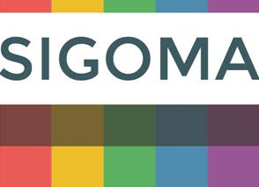

The Special Interest Group of Municipal Authorities (Outside London)

**SIGOMA RESPONSE TO THE 2020-21 PROVISIONAL LOCAL GOVERNMENT FINANCE SETTLEMENT CONSULTATION**

1. **About SIGOMA**
   1. This submission is made on behalf of SIGOMA, the Special Interest Group of Municipal Authorities. We welcome the opportunity to respond to the consultation.
   2. SIGOMA is a special interest group (within the LGA) representing 47 local authorities covering key urban areas in the North West , East and West Midlands, the North East, Yorkshire & Humberside and the South-coast ; consisting of 33 metropolitan districts and 14 major unitary authorities.
   3. SIGOMA councils comprise 6.1 million households, over 25% of England’s total[1]. However SIGOMA collect just 19 percent of the nation’s total Council Tax and 18.6% of the nation’s business rates, according to 2019-20 estimates[2].
   4. At the same time our members are striving to provide services to a population that includes a disproportionately high number of those most affected by changes to the welfare system. For example over 1/3rd of unemployment benefit claimants are from SIGOMA council areas[3] and 36% of all looked after children[4].
   5. Members were encouraged by the Prime Ministers speech on the steps of Downing street in which he promised a levelling up across the country. This matches our aspirations for the settlement, which we feel so far has fallen short in two key areas.

* matching funding need and the cost of services, particularly care services
* recognition of the variation in tax raising capacity of councils reflecting the strengths and weaknesses in local economies that has been underpinned by varying infrastructure investment.

1. **Extension of the Re-set Period**
   1. Since the introduction of business rate retention in 2013 income from business rates has grown organically and through inflation by around £3 billion (30%) [5], much of that growth unrecognised in Core Spending Power. Over the same period, income from Council Tax has grown by £6.2 billion (31%) including the social care precept, and New Homes Bonus has paid £7.3 billion as an unringfenced housing growth incentive.
   2. Whilst incentive and growth allocations have increased over 2013-14 to 2019-20, as described above, overall Settlement funding has fallen by more than £1billion in cash terms. This means that formula, needs-based funding has borne the overwhelming brunt of cuts. Revenue Support Grant fell from £15.2 billion in 2013-14 to £3.8 billion in 2017-18 and continued to fall due to cuts in Settlement funding up to 2019-20.
   3. This swing towards internally generated income and growth benefits some authorities much more than others and creates a better overall impression than is the case for many of our members.
   4. This is illustrated in the following chart which shows the magnitude of the impact growth in business rates above baselines has had relative to Core Spending Power. In the chart, we compare 2018-19[6] business rates growth-above-baseline to Core Spending Power totals for 2020-21. Whilst 18 councils added more than 30% to their Core spending power as presented in 2020-21 CSP tables, others were below their CSP amounts. SIGOMA authorities are shown in red on the chart and all are below the national average of 9%

**Business Rates £ Growth above Needs Baseline as a Percentage of 20-21 CSP[7]**

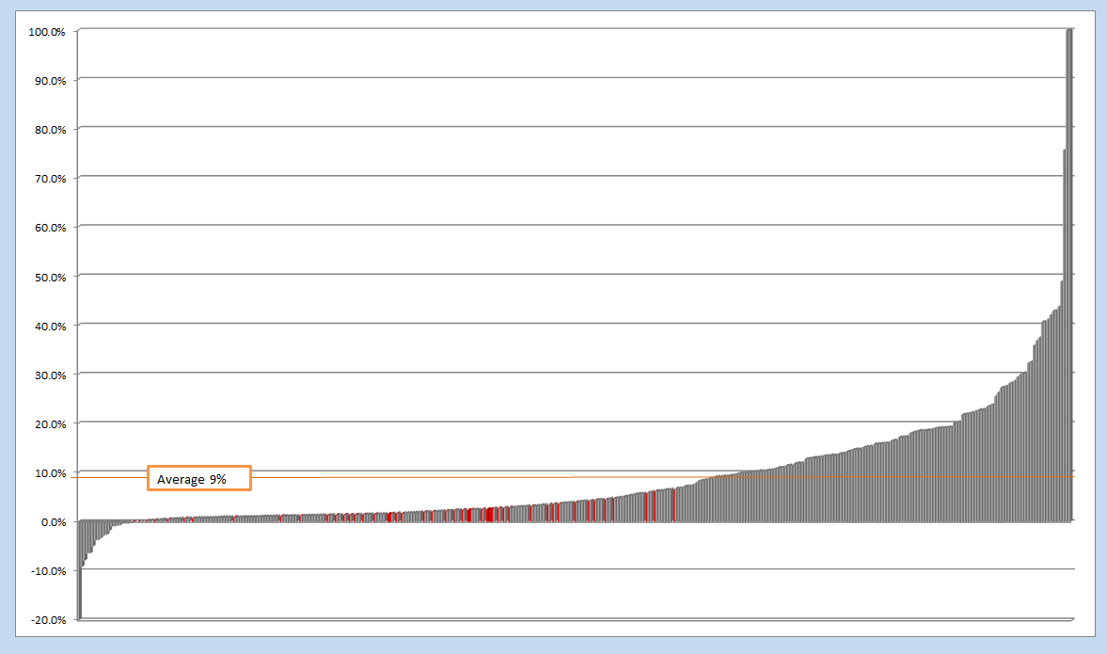

\Consultation responses (copies)\[settlement provisional1_rates growth.xlsx]Sheet1

* 1. These figures are a conservative estimate in that:
* They are at a 50% retention level whilst some devolution pilots are on higher rates
* They ignore increased growth in 2019-20 (and no doubt 20-21)
  1. This illustrates the disproportionate benefit conferred on some authorities by extending re set to 2021. That additional growth, or a portion of it, could be directed towards the chronically underfunded Children’s Social Services.
  2. It can easily be seen that authorities with weak local tax bases and modest housing growth will not be able to obtain the same benefit from this policy for 20-21 as their more affluent neighbours, yet at the same time they are frequently experiencing above average demand for services.
  3. The proposals for 2020-21 in the Settlement for Better Care funding based on demand go some way to towards alleviating pressure, but they still continue and extend the policy of reliance on local resource and incentive. Hence, of the headline £2.9 billion increase in Core Spending Power only 34%, £1 billion, is direct, needs-based grant, the majority being from business rates and Council Tax growth.
  4. The extension of re-set prolongs this imbalance and will disadvantage the majority of our members, a matter not recognised by Government despite their readiness to compensate certain councils with transition funding in recent years. We recommend that councils worst affected by a delayed re set in terms of Settlement Funding should be compensated for this decision.
  5. In addition some members have repeated their concern at the risk to business rates income caused by appeals and the necessity for appeal provisions. It is appreciated that the Department are working towards a method of pooling the effect of appeals and we await the outcome of this with interest.

1. **Other Issues**
   1. Our members request a timely notification of **public health grant** allocations. A real terms increase has been promised yet no allocations have yet been announced with only 11 weeks remaining until the new year commences.
2. **Q1 Do you agree with the Government’s proposed methodology for the distribution of Revenue Support Grant?**
   1. From 2016, RSG adjustments (reductions) have been made on the basis of a spending power total that took into account a baseline core Council Tax income for each authority.
   2. In previous years, SFA was falling whilst Council Tax increased. This made a significant difference to allocations but with the increase in SFA and Council Tax referendum cap closely aligned this year, the distributional impact in this year is less.
   3. Given our comments in section 1 and 2 it will be understood why we feel that the 2016 system should continue and, moreover, should take into account an updated 2019-20 baseline value for Council Tax. This will ensure a more uniform benefit across authorities from the various funding streams. Given the point made in 3.2 above however we agree with the proposed methodology, for this year only.
3. **Q2 Should central government eliminate negative RSG in full through foregone business rates receipts?**
   1. The consultation does not disclose the cost of this proposal or the councils who benefit and by how much. In 2016 the estimated cost in 2019-20 was £152 million. This is not an inconsiderable amount though the 20-21 policy for RSG growth would likely reduced the overall total. The Department should disclose the cost of this policy.
   2. If the Department strives to distribute as much funding as possible consistent with prudently withholding funds that may be needed for contingencies and if all business rates are used for local government purposes then funds taken from central rates share are not additional.
   3. The argument for removing negative RSG in its early years was that those authorities affected had not had time to react to the proposed changes.
   4. Of course the Department has made year on year reductions to settlement funding via RSG every year since 2010 and it is difficult for our members who have been worst affected by these reductions to distinguish this particular reduction in RSG from the others that have impacted so heavily on them.
   5. The notion of negative RSG is of course meaningless within the rate retention system. Every Tariff authority suffers a negative adjustment to its central funding, an inevitable consequence of the rate retention system created by the Department. In 2016-17 222 authorities had a negative adjustment, a Tariff, that was greater than their RSG, by an aggregate £3,118 million
   6. In our 2018 consultation response we produced tables that compared cuts to Core Spending Power with the various add-on grants that had been introduced by Government to alleviate perceived losses from funding cuts, it showed that some of the lowest cut authorities had been reimbursed RSG whilst some of the highest cuts had not:

**From consultation 2018**

**Highest and lowest cuts to core spending power**



* 1. Therefore we do not support the extension of refunding negative RSG and suggest that if Government has now decided it still has funds available within rate share to distribute to councils this should be distributed to all councils, based on need.

1. **Q3 Do you agree with the proposed package of council tax referendum principles for 2020-21?**
   1. We have already highlighted the consequences of making councils more dependent on locally raised taxation. Under the existing funding mechanism, without equalisation, this causes a mismatch between funding and needs which works to the disadvantage of most of our members.

**Ratio of Council Tax to Core Spending Power All councils – SIGOMA in red/white**

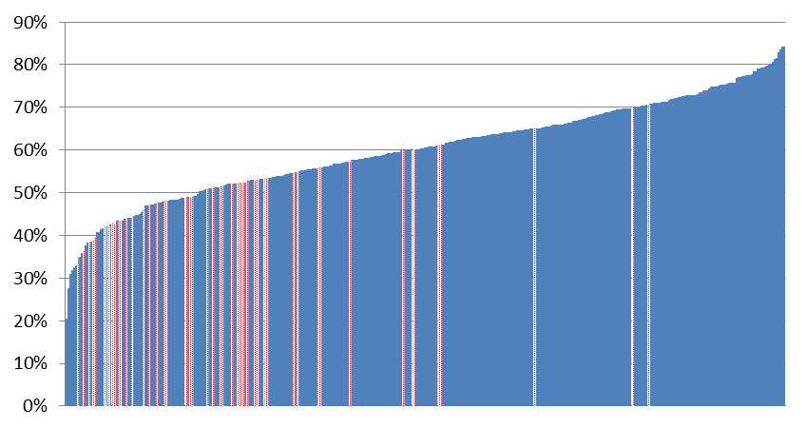

Average

Settlements\2019-20\[Core Spending Power_supporting_info Draft.xlsx]2019-20

* 1. There is little doubt amongst our members that the Council Tax system stands in need of an overhaul. This view has been endorsed recently by the Housing Communities and Local Government Committee in their report[8] which includes the recommendation that:

*A revaluation for council tax purposes is long overdue. The Government should hold a review into how a revaluation could be implemented without dramatic increases for individual households. Any revaluation should be revenue neutral at the national level.*

* 1. We support the LGA in their call for removal of the referendum cap and in a call for a review of the Council Tax system.
  2. We call for an equalising adjustment between councils to recognise the different tax raising capacities of councils.

1. **Q 4 Do you agree with the Governments proposals for Social Care Grant 2020-21?**
   1. It is welcome that the Government has recognised the importance of social care funding in this settlement. It is disappointing that the Department has chosen to make its announcement of additional funding an all embracing reference to adults and children’s social care without any evaluation or recognition of the dual pressure created on councils by both these services.
   2. To over focus on adult social care would be to miss a looming pressure that ranks equally with adults and presents authorities with a comparable unavoidable and uncontrollable demand. Together, Children’s and Adults Social Care now represent over half of council net service expenditure[9] and both have been protected by councils to the detriment of other services or reserves in a way that is not sustainable without further funding for both. In a recent survey of our councils conducted during a meeting councils were asked to risk assess care services in a RAG rating, many members showed children’s services as a Red rating, with urgent funding pressures.

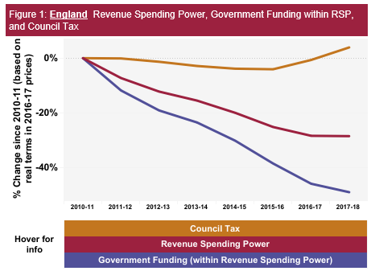

GF

CT

RSP

The charts opposite and below show that whilst spending power has been falling dramatically, -28.5% in real terms to 2017-18, spending on adult and children’s social care has been sustained in recognition of the high risk associated with these services

(Source ONS 2018 data visualisation, Revenue Spending Power)

footnote[10]

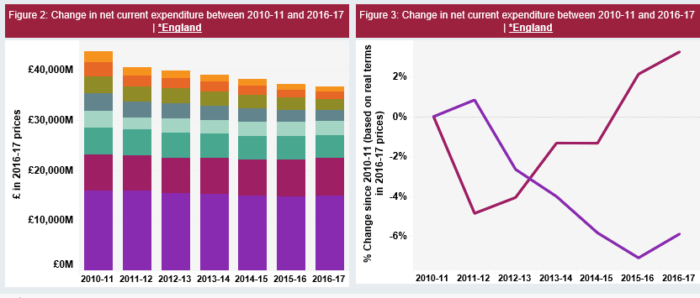

Adults

Children’s

* 1. Therefore the additional funding, whilst welcome is not adequate to sustain both services and should be increased
  2. The above spend profiles are of course averages. Within those averages the poorest councils have had to make the harshest cuts. So for example on a comparable basis Barnsley reduced its expenditure on Children’s social care by 16.7% and on Adults by 18.6% whilst Surrey County Council increased its expenditure on Children’s social care by 13.2% and on adults increased it by 21.3% over the same period.

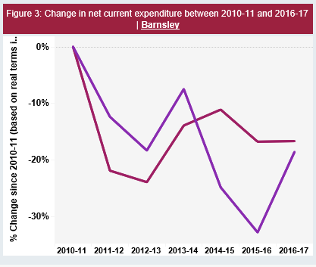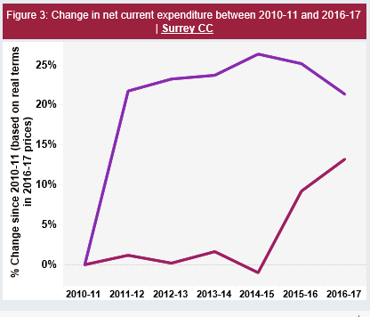

Adults

Adults

<https://www.nao.org.uk/other/financial-sustainability-of-local-authorities-2018-visualisation/>

* 1. The method used for allocating the additional £1 billion social care grant does not follow the precedent set in previous allocations which was that 10% of the additional money would be allocated according to 2013 adult social care formula with the remaining being allocated as a combination of grant and social care precept of that year, after which the precept is deducted. No explanation has been provided for this change. We recommend that the published process for supplementary funding should be followed in order that councils who have been unable to raise sufficient funding through council tax have this recognised <https://assets.publishing.service.gov.uk/government/uploads/system/uploads/attachment_data/file/598252/EN_FINAL.pdf>
  2. The impact of the chosen distribution method at council level can be seen in the following table which compares the percentage growth in social care funding from Social Care Precept and Social Care Grants at authority level.
  3. In the absence of a new needs formula, one would expect the percentage growth in a fair distribution to be about the same for all councils. There is in fact a 10% variation between the highest and the lowest growth percentages:

**Increase in Social Care Funding 2020-21 Highest and Lowest Percentage Growth**



* 1. Even ignoring possible outliers in the above tables, there is a clear dividing line between more and less prosperous councils at the extremes. **The allocation basis needs to change to address this disparity.**
  2. Most of our members feel however the existing distribution method of the grant is flawed in any event in that it does not fully recognise the burden of Council Tax that some tax payers are carrying by comparison to others.
  3. The equalising adjustment compensates authorities for their varying ability to raise tax but it also compensates them for their local choices of band D tax levels.
  4. We have already referred to the comments of the Housing Communities and Local Government Committee on the need for reforms to the Council Tax system, the problems manifest themselves in this allocation in that any authorities who have maintained a relatively low band D and overall Council Tax level are rewarded for doing so by increased social care grant under this allocation.
  5. The problem could be rectified in this allocation by using a notional band D value to allocate the overall value of the social care precept of circa £500 million. Hence in the method used by MHCLG authorities would have their allocation of £650 million reduced by a **notional** precept value which fairly and equally reflected the tax base of each authority. This equalising adjustment may require a second adjustment to eliminate resultant negatives.
  6. The precedent for this is already established in the current and proposed resource adjustment in the funding formula and again places equal proportions of funding where it is most needed.

1. **Q5 Do you agree with the Governments proposals for Improved Better Care Funding in 2020-21?**
   1. Our response should be read in conjunction with our response to question 4.
   2. Members agree that social care grant should be continued and indeed extended. As has been noted by the HCLG Committee it is highly desirable to move away from year-on-year hand to mouth funding and towards a more stable and predictable funding stream that reflects demand at a local level. It should be a priority of Government to secure a longer term funding stream for care services
   3. There is emerging concern amongst members however that, immediately following the funding announcement , National Health Service Directors have begun manoeuvres to hypothecate some of the published increase against costs which are not the responsibility of Councils under current arrangements, namely:

* Using the increase to fund increased pay costs for “Agenda for Change” for which they have previously had one-off in year funding from Government
* Using the funds to increase HIV PrEP provision, a cost it appears they are trying to unilaterally pass on to local authorities without additional funding
  1. If both, or either, of these concerns prove to be correct then Government cannot state that authorities are receiving an increase in pooled funding since this is being absorbed by increased financial responsibility
  2. Due to issues like the ones raised above, many members feel constrained by the need to pool IBCF funding into the Better Care Fund. Whilst recognising and supporting the need for cooperation between health bodies they feel a higher level of autonomy would help them to more proactively address joint issues.

1. **Q6 Do you agree with the Governments proposal to fund the New Homes Bonus 2020-21 with the planned £900 million from Revenue Support Grant, with additional funding being secured from departmental resources and to allocate the funds in line with previous years but with no legacy payments?**
   1. The topslice has clearly hit our members hardest.
   2. Whilst members support the principle of a formula allocation based on housing need, the vast majority do not support New Homes Bonus in its current form and particularly as currently funded.
   3. The great majority of our members would prefer to see the available funding channelled back into Settlement funding from where it has been taken and applied in proportion to Settlement Funding shares.
2. **Question 7 Do you agree with the Governments proposed approach to paying £81 million Rural Services Delivery Grant in 2020-21 to the upper quartile of local authorities based on the super sparsity indicator?**
   1. We have objected to this grant on previous occasions and continue to do so on the grounds that:
   2. the amount and allocation has not been justified on any occasion or supported by any objective statistical analysis
   3. sparsity is already included in the formula that underpins settlement funding and
   4. many authorities that benefit most from Rural Service Grants have already befitted extensively from:

* Transition grant
* Negative RSG adjustment
* Generous shares of business rate growth
  1. It is significant that, despite the inbuilt majority of shire areas in council surveys this proposal did not have the majority support of members.
  2. We therefore do not agree with the proposal and suggest the amount is added to settlement funding.

1. **Q8 Do you have any comments on the impact of the proposals for the 2020-21 settlement outlined in this consultation document on persons who share a protected characteristic?**
   1. Having recently conducted an in depth examination into the profile of costs of children’s services (jointly with DfE) the Department will hopefully be in a good position to project the real cost of delivering these services in an environment where demand is increasing.
   2. The prospect of an under-funded, and therefore under-supported children’s social service cannot be encompassed. This was highlighted in our document, “no investment no future document[11]” this year, showing that child protection assessments have increased by 126% since 2010 whilst services focussed around our poorest youth such as youth centres and libraries have declined, with authorities increasingly focussed on core statutory services.
   3. We are already seeing the consequences of this for our poorest young people with a healthy life expectancy gap of 18 years between the poorest and wealthiest and children from low income households twice as likely to suffer mental health issues.
   4. Badging better care money as adult and children’s care will not address this issue unless the overall quantum is adequate. This is even more difficult to accept in a year where around £1.8 billion of funding that should have been distributed according to needs continues to be allocated on the basis of growth
   5. Government seem more aware of the pressures surrounding our dependent elderly population.
   6. Yet the tension between authorities and care providers is increasing due to lack of funding and there have already been headline illustrations that the care system is at breaking point[12],[13]
   7. The Settlement was viewed by adult care directors as “a step in the right direction to stop things getting worse, but much more is needed in terms of long term funding and a long term plan if social care is to really support older and disabled people to live better lives”.

1. As recorded by MHCLG in their core spending power tables 2019-20
2. From MHCLG Core Spending Power 2019-20 and NNDR 2019-20 Non Domestic Rating Income forecasts.
3. Nomis - Claimant count 2015 to 2019, figures are distorted by roll out of universal credit. Actual percentages were between 37% & 34.8% over those years and are likely to be significantly over 1/3rd.
4. DfE - Children looked after in England 2017 to 2018
5. Calculated at 50% retention, including s31 grants, for pilots the rate is higher
6. This is the last year calculated by MHCLG at 50% retained local shares.
7. Does not include the results of 9 newly formed or reformed authorities e.g. Bournemouth, Christchurch and Pool and Buckinghamshire Council
8. <https://www.parliament.uk/business/committees/committees-a-z/commons-select/housing-communities-and-local-government-committee/inquiries/parliament-2017/inquiry18/>
9. Excluding schools
10. Adult Care at 10-11 £15,847m at 16-17 £14,914m;Children’s at 10-11 £7,319 at 16-17 £7,556; at 16-17 prices
11. <https://www.sigoma.gov.uk/__documents/No-Investment-No-Future.pdf>
12. https://www.adass.org.uk/adass-responds-to-carers-uk-report-carers-at-breaking-point
13. https://www.thirdsector.co.uk/half-social-care-providers-handing-contracts-back-local-authorities/finance/article/1525528