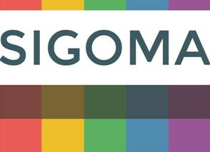

The Special Interest Group of Municipal Authorities (Outside London)

SIGOMA RESPONSE TO THE PROVISIONAL LOCAL GOVERNMENT FINANCE SETTLEMENT

- About SIGOMA
  - This submission is made on behalf of SIGOMA, the Special Interest Group of Municipal Authorities. We welcome the opportunity to respond to the consultation.

  - SIGOMA is a special interest group (within the LGA) representing 47 local authorities covering key urban areas in the North West, East and West Midlands, the North East, Yorkshire & Humberside and the South-coast; consisting of 33 metropolitan districts and 14 major unitary authorities.

  - In demographic profile SIGOMA councils comprise 6.1 million households, over 25% of England’s total but are over-represented in poverty indicators and the related demand for services whilst at the same time under-represented in terms of council tax and business rate earnings, which are increasingly influential in the funding framework for local government

- Q1: Do you agree with the Government’s proposed methodology for the distribution of Revenue Support Grant in 2021-22?

  - Since MHCLG include Settlement Funding within this part of the consultation we also include Settlement Funding within our comments. We cannot agree for the reasons below.

  - The whole of core spending power comprising council tax, settlement funding and various grants, is better than many councils had feared in the context of the financial crisis precipitated by covid, but very far from that which would have been hoped for at the beginning of 2020 in terms of distribution.

  - The continuation of business rate growth retention is now having a hugely distorting effect that is rendering the Core Spending Power figure itself meaningless and is not being redressed within Revenue Support Grant.

  - For 2018-19 MHCLG made their own projection of growth above baseline for which the England total was £1.4 billion. We have produced our own estimate of the equivalent figure for 2020-21 which indicates growth above baseline of £1.9 billion.

  - This growth of nearly £2 billion was not reported in Core Spending Power nor, now, will it be recorded in 2021-22 yet it represents an additional 3.9% of 2020-21 core spending power overall.

  - The distributional effect of this un-recorded growth on authority relative funding is immense. The chart below shows the percentage of additional core spending power that the growth represents for comparable authorities .

2020-21 Business Rate Growth as a percentage of Core Spending Power
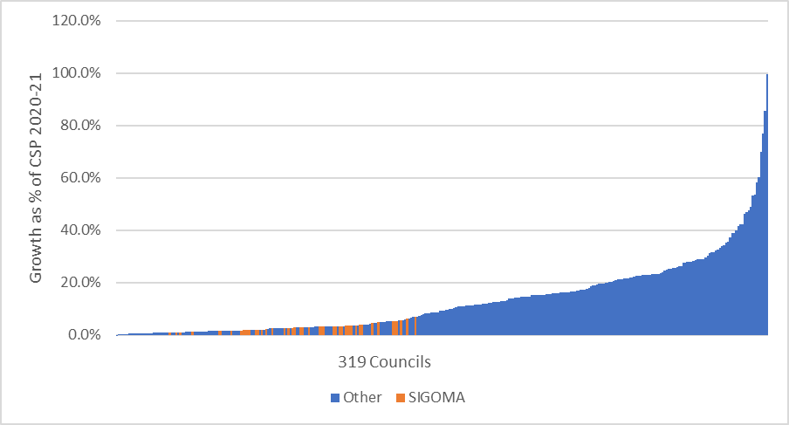

  - The table illustrates how skewed the effect is against the poorer councils we represent and supports our assertion that the huge majority of our members lose from this decision. We estimate the loss to our members in 2020-21 alone to be in the order of £225 million.

  - This is the major disparity that should be the subject of loss compensation in RSG, not negative RSG or protecting zero % loss in core spending power in Lower Tier Service Grant.

  - We will refer to this point again in later sections.

- Q2 Do you agree with the proposed package of council tax referendum principles for 2021-22?

  - No

  - Our members concur with the view of the LGA that increased reliance on council tax to fund the breadth of council services is both unfair to local taxpayers and does not correlate with how the demand for services arises.

  - Of the 4.5% cash terms increase in core spending power 3.9% is made up of council tax increases (or 86% of the headline £2.2 billion increase).

  - Since RSG is not being adjusted to reflect the greater core tax earning capacity of some councils compared to others, funds are not being raised in proportion to need.

  - With respect to the Social Care Premium it is time that government ensured a needs-based distribution of the combined effect of the social care premia, social care grants and the improved better care fund for a consistent and logical distribution of funds

- Q3: Do you agree with the Government’s proposals for the Social Care Grant in 2021-22?

  - The answer would be a qualified yes.
  - See also our response to question 2.

  - The allocation of the social care grant has been used to partially equalise the unequal effect of the social care precept which is welcome

  - Members still feel, however, that government should be clear about the priority of funding adult and children’s social care adequately, in terms of overall funding, as recommended by ADAS and the LGA, and in a manner that distributes the 3 main funding streams of Social Care Precept, Social Care Grant and Better Care fund according to social care needs formula.

- Q4: Do you agree with the Government’s proposals for iBCF in 2021-22?

  - See also answers to question 2 and 3.

  - It is welcome that Better Care Funding is being sustained under current circumstance.

  - It would be possible to ensure no losers in terms of core spending power yet adjust IBCF to reflect updated adult social care premiums and social care grant over the life of better care, or at least in 2021-22.

- Q5: Do you agree with the Government’s proposals for New Homes Bonus in 2021-22?

  - As we have explained in previous submissions. Our objection to new homes bonus is not the bonus per se but the fact that it has been funded by RSG top-slice and has been growing whilst RSG reduced.

  - To the extent that the proposals reduce New Homes Bonus, leading to increased RSG funding, Members support the proposal in this year, but with the added comment that they would prefer to see an alternative incentive for new build that was not financed from settlement funding, but rather formed part of overall needs financing.

  - We look forward to making these points in the promised review of NHB.

- Q6: Do you agree with the Government’s proposal for a new Lower Tier Services Grant, with a minimum funding floor so that no authority sees an annual reduction in Core Spending Power?

  - On balance, the answer is no.

  - key to protecting lower tier services is an adequate overall funding package that encompasses critical care, preventative services and other services which, though not critical, underpin the fabric of communities and support quality of life.

  - We note that this grant has also been used to uplift councils who would otherwise have a negative reduction in core spending power.

  - We refer again to our comments in section 2. The core spending power information is not an accurate measure of the relative funding of councils since it excludes business rates growth which should rightly have been redistributed on a needs basis at April 2020.

  - As we have shown, BR growth has disproportionately benefitted some councils in 20-21 and will no doubt do so again in 2021-22, many of those receiving CSP top-up are amongst the greatest beneficiaries from BR growth.

  - We therefore suggest that an indicative loss due to deferring re-set should be included in 2021-22 core spending power adjustment.

- Q7: Do you agree with the Government’s proposals for Rural Services Delivery Grant in 2021-22?

  - No

  - Rural Services Grant has grown from £16 million since 2015-16 i.e. has grown by 530% when all of core spending power grows by just 15% and Settlement Funding declines by 30%.

  - In this context the increase is unsupportable.

- Question 8: Do you have any comments on the Government’s plan not to publish Visible Lines?

  - On balance, no.

  - Whilst this issue is not of primary importance to the average member the prevailing view is that until government undertakes a full spending review it would be appropriate to continue to publish visible lines.

  - Effectively the same funding policy is being continued and this should be capable of reconciliation to its sources until such time as a proper review tales place.

  - By the same token members feel that the core spending powers should differentiate between the different elements of council tax (at least social care precept and other)

  - Additionally, members would like to see official published Business Rates Growth retention figures for 2019-20, 2020-21 and for 2021-22 when available.

- Question 9: Do you have any comments on the impact of the proposals for the 2021- 22 settlement outlined in this consultation document on persons who share a protected characteristic, and on the draft equality statement published alongside the consultation document?

  - We repeat our previous comments that under-funding particularly of care services and a lack of coherent national policy on adults and children’s social care cannot but have a detrimental impact on some of the most vulnerable people in our community.

  - The parlous state of adult social care is illustrated by a recent announcement by James Bullion ADAS president:

“Like our NHS colleagues, social care workers have never been under such pressure. They are doing more than ever before, but absences are high and rising and our capacity to keep vital services going is at grave risk.
“We need funding, now, to enable care providers to recruit extra skilled pairs of hands and we are asking anyone who has done care work in the past to think very seriously about returning to help us get through this. Every single person who steps forward will be making a huge contribution.”
  - Government have created a temporary stop gap by throwing money at the problem in 2020-21 but the impact of covid is clearly still with us and the underlying problems are not going away

  - The state of Children’s’ care is, if anything, more perilous if only because it seems to be passing under Treasury radar as a problem

  - Again, quoting the ADCS chair.

Poverty is not inevitable or ‘someone else’s problem’. There is not only a moral imperative for urgent government action but an economic imperative too: improving the circumstances in which children live today will support them to develop into well educated, well developed adults who actively contribute to society. Levelling up children’s life chances should be the cornerstone of the government’s ambition to ‘level up’ society.

  - Re-badging adult social care funding as “Adults and Children’s care” and leaving councils to chose between the two is an abrogation of responsibility by an administration that holds so much control over funding and the statutory framework.

  - In compiling the Fair Funding formula for children’s services, government had a unique opportunity to assess the true cost of providing support to children and families

  - As we have stated in our submission to Treasury on the Spending Review, and now the Budget, there has been unprecedented interaction between local officers and leaders and Whitehall during covid. Government has a chance to build on this with a truly inclusive review of what is needed to support the elderly, vulnerable adults and children.

As recorded by MHCLG in their core spending power tables 2019-20
At 50% retention, excludes smaller s31 payments so is likely understated. Levy calculated at pool level
319 councils, excludes fire; Due to changes in authority combinations some LAs are excluded
Calculated by comparing local authority retained growth to a theoretical allocation of £1.9 billion based on settlement funding allocations. 41 out of 47 SIGOMA councils lose from this comparison
Jenny Coles ADCS president 23 October 2020

